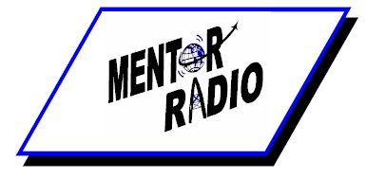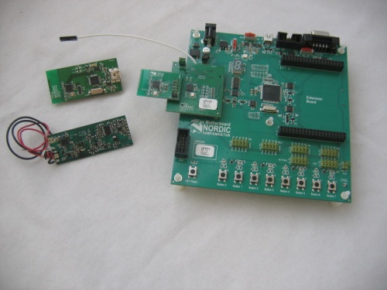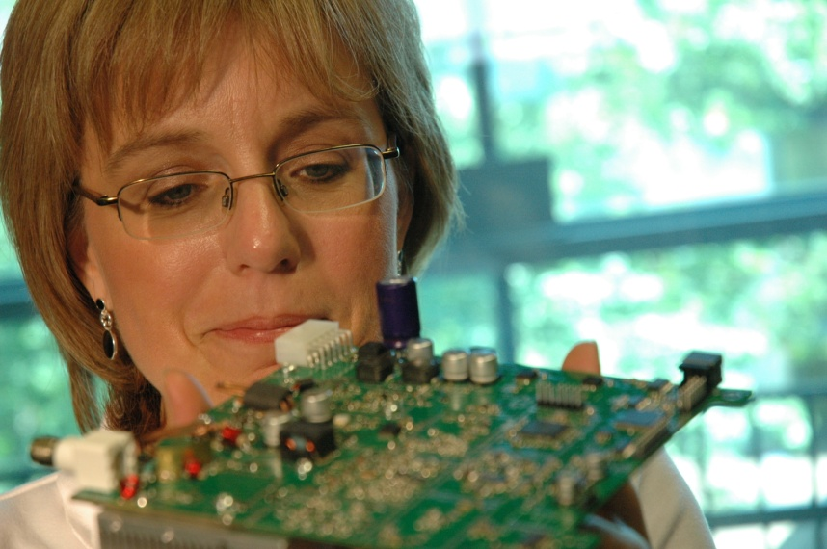te

***CONSULTING***

**solutions/consulting**

**SOLUTIONS/CONSULTING**

**consulting**

System Engineering

Hardware

Firmware Manufacturing

**consulting**

system engineering

hardware, software & firmware development

151 Innovation Drive, Ste 320

Elyria, OH 44035

216 265 2315 ph

216 267 2915 fax

www.mentorradio.com

Engineering

Technology

technology

**CONSULTING**

Mentor Radio can help you transform your ideas into profit generating products. We provide custom engineering consulting services for both hardware and software design.

Call us today to discuss your project or e-mail Mentor Radio at [sales@mentorradio.com](mailto:sales@mentorradio.com). Check us out at www.mentorradio.com.

Engineering **SOLUTIONS**

Engineering

Technology

Mentor Radio can translate your ideas into usable profit generating products or provide solutions for your design issues. We provide consulting services for a broad range of engineering challenges. Let us analyze and troubleshoot your design issues.

Mentor Radio has over 60 years of combined communication system design, development and testing experience, specializing in providing custom electronics, firmware, software, and fiber optic solutions.

Technological advancements have changed the marketplace from simple product based solutions to completely integrated system solutions. Providing these systems requires a broad range of expertise that is difficult for many companies to staff and maintain.

Mentor Radio helps companies provide solutions to these challenges. We offer companies everything from low-volume, high quality products to high volume, low-cost products for commercial, medical, and military applications.

Mentor Radio brings mature business judgment and experience to help you sort through your greatest engineering challenges and will help you meet your business objectives.

**Let Mentor Radio Provide**

**The Solution To Your**

**Engineering Challenges!**

**S o l u t i o n s** At Work For You

**engineering** **SOLUTIONS**

* **Analog design & Systems**
* **digital design & Systems**
* **circuit design, EVALUATION &TESTING**
* **COMMUNICATIONS SYSTEM ENGINEERING AND EVALUATION**
* **dsp solutions (digital signal processing)**
* **distributed antenna systemS**
* **FCC CERTIFICATION**
* **MICROCONTROLLER SOLUTIONS**
* **MIXED SIGNAL SYSTEMS**
* **radio over fiber/Optical systems**
* **SBIR’S**
* **software & embedded software**
* **wireless STANDARDS (Bluetooth, zigbee, 802.11, cdma, qam, ofdm, and more!)**

**customers/clientS**

**Acense, llc**

**bryter technologies**

**circle prime manufacturing**

**corning, inc.**

**hallsten innovations**

**omega micro technologies**

**Spectre corp**

**turning technologies**

**usa firmware**

**Vanteon Corporation**

**• Communications System Engineering**

**• Design Simulation**

**• Hardware & Software Development**

**• Material Management & Procurement**

**• Multi-Layer PCB Design & Layout**

**• Product Design, Development, Evaluation, & Testing**

**• Product Integration Services**

**• Prototypes & Design for Manufacturability**

**• Solid State Systems**

**• System Analysis**

**solutions your business needs**

**ENGINEERING TECHNOLOGY**

ENGINEERING SOLUTIONS

Solid State Systems

Design Simulation

Hardware Development

System Analysis

Wireless Networks

Optical Systems

RFTesting

Multi-Layer PCB Design & Layout

Prototypes & Design for Manufacturability

MANUFACTURING SOLUTIONS

Automated Testing

CAD

Machine Shop

Product Integration Services

Material Management & Procurement

ELECTRONIC SOLUTIONS

We specialize in providing custom electronic, firmware, software and fiber optic solutions for a variety of applications.

• Mos ventosus feugiat blandit turpis vero abigo.

• Mos in dolor, aliquip illum neo adipiscing iriure.

• Autem verto illum cogo vulputate aliquam velos.

• Consequat nostrud, pneum, ibidem ex.

• Ullamcorper quibus, velit distineo oppeto.

• Consectetuer refero ut nimis vulputate quadrum.

• Delenit proprius foras patria vereor, duis facilisi.